Dialogue Manager

Dialogue Manager is a script that controls the whole system. It uses the Unity Scene Manager, which is only related to the functioning of the whole project and is not important for the functioning of the component. This script is attached to an empty object in the scene.

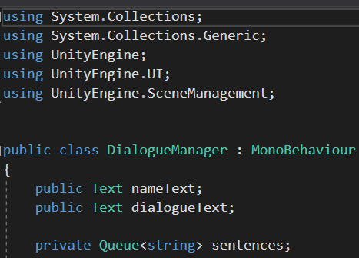

In the first lines are declared two text boxes containing the name of the NPC that will communicate the dialogue, dialogue text itself and a queue with sentences of type string.

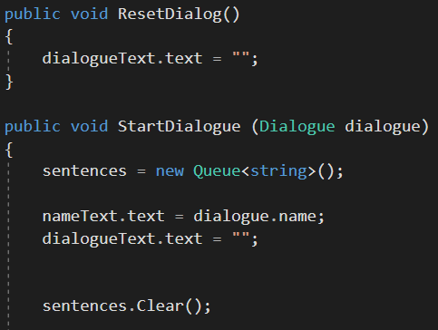

The programs will start with resetting the dialogue every time it is run. Then will start with picking up the Queue and the text boxes and clear them after being displayed.

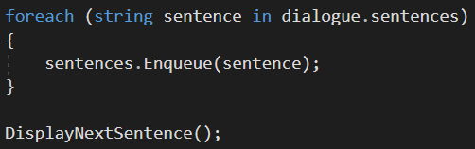

These lines display the next sentence in the Queue.

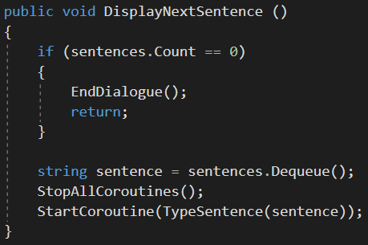

Here the program check if there are no more sentences in the queue and finish the dialogue. The last line declares a coroutine

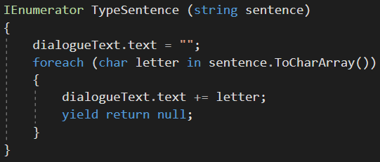

that picks up every letter of the sentence and create an array to display it one by one, that simply makes it look like it is being typed now.

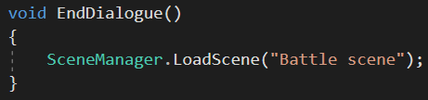

The last lines of this class load a chosen scene, this is only for the purposes of the whole project and it is not necessary for the functioning of the component.